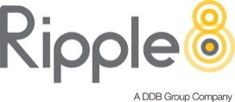 | CONFIDENTIAL
 | DIGITAL CAMPAIGN BRIEF

CLIENT: | Meralco
PRODUCT: | Power Alerts
CAMPAIGN: | Digital Advertising
DATE SUBMITTED: | October 20, 2022
DATE DUE:

BACKGROUND

Year on year, Meralco faces a problem regarding low power supply in during summer months. It is a problem that cannot be avoided; thus this creates a ripple effect to its customers making them assume its Meralco’s doing.

The Luzon Grid has been experiencing periodic supply tightness for years and this is largely dictated by the availability of power plants that is affected by age and fuel sources.

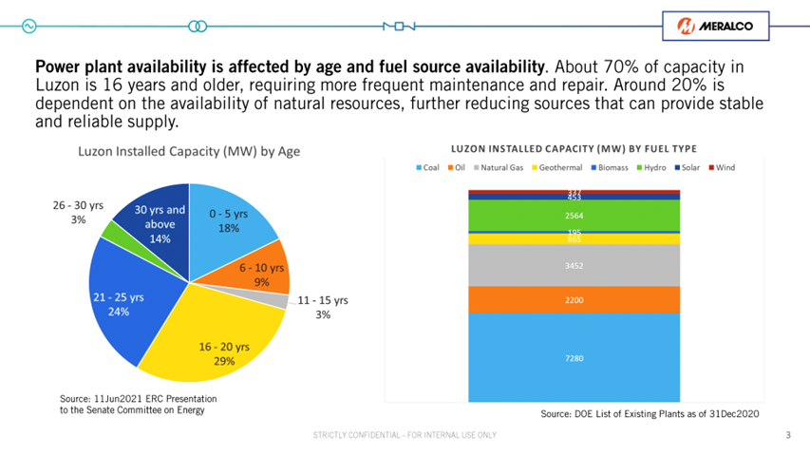

With the increase of electricity usage in summer usually comes a shortage or thinning of supply across the power grid. This 2022, DOE warned of yellow alerts during the summer months due to thin power reserve and continuous increase in demand.

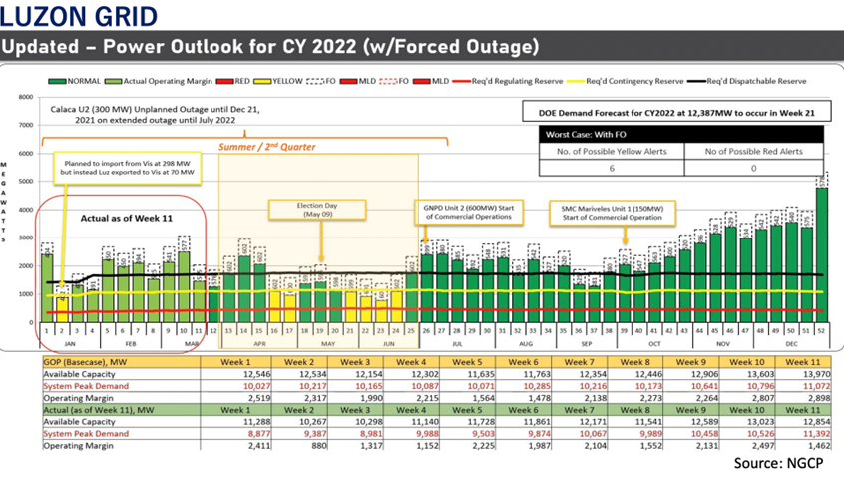

With this, we would want customers to be ready in preparation for summer of next year and not be blindsided by the shortages.

OBJECTIVES & CHALLENGE

COMMUNICATION OBJECTIVE:

1. To educate customers on the Power Ecosystem and its different players for customers to better understand how electricity is delivered to their homes.
2. To increase customer awareness on the causes of power supply shortage and how this can be mitigated.
3. To empower customers to act now and to contribute to ensuring that power is available all-summer-long.
4. To inform customers on what to do when they experience rotational brownouts and encourage use of self-service and digital channels.
CHALLENGE:
Consumers perceive MERALCO as a necessary but not that trustworthy institution that they readily blame for problems for power shortage & price increases

TARGET AUDIENCE

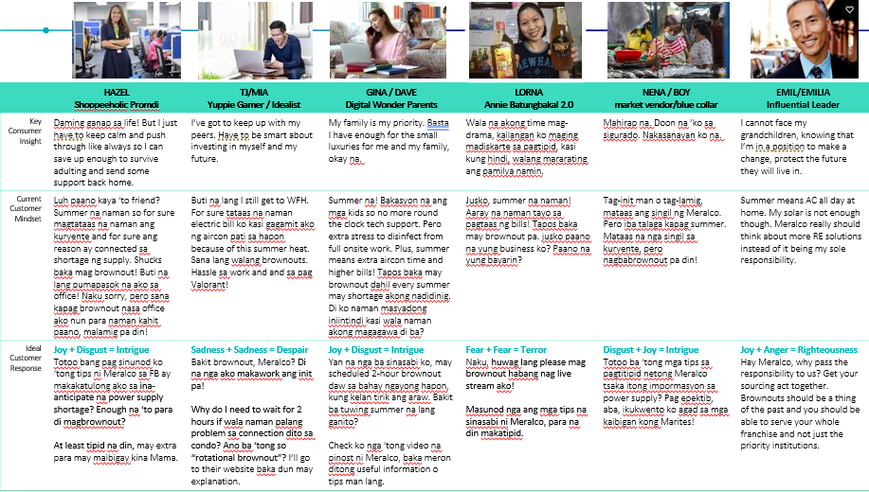

MESSAGING:

Give informative yet simple messaging for the mass to understand the situation that yearly happens. Entice them to be more responsible to be more aware on energy updates and let our customers understand “the power is in your hands” despite shortage of power in the months to come.
TASKS:

- A new look for power alerts template (Sending in a different attachment past looks of Power Alerts)
- An education campaign to teach our profiles the meaning of the different alerts just so that they know what to do and how to prepare for instances when we announce power alerts

DESIRED OUTCOME

Approaching it this way can show us the ONE BIG THING this campaign has to achieve that is measurable - help improve MERALCO trust rating from 34% to 50%

DELIVERABLES

- Social Media (Facebook)
  - Static + GIF
  - Video (6s and 15s)

- Digital (Youtube and VOD)
  - Video (6s and 15s)

ADDITIONAL INFORMATION

Tonality
Brand Archetype
- “The Caregiver” or “The Kind-hearted friend”

Personality Voice
- “Service with Compassion”
- Confident
- Warm
- Friendly
- Empathetic
- Knowledgeable
- Proactive

Tone
- Lively/energetic
- Inspiring

NOTES:
- Have materials specifically “catered” to each target market different approach with the aligned messaging for this campaign. (Lorna, Nena, Emil, TJ, etc.)
- To follow brand guidelines and colors

TIME FRAME

Estimate: Ber months – Q1 just in time for Summer Season
Written by: Approved by:

____________________________________________ ____________________________________________
(Client/Agency) (Client)

____________________________________________
(Agency)

